Chapter 1

Introduction

Any project goes through multiple phases such as project planning, requirements analysis, project design, construction, testing, integrating, deployment and maintenance. These phases can be referred to as life cycle of a project.

Project that is been assigned and expected to be delivered is a database management system with a client - server interaction where the client (user) should be able to request and get access to the database on the server side and add new entries to the database.

The constraints laid by the university on the database management system mini project are as follows:

* For any problem selected, write the ER Diagram, apply ER-mapping rules,normalize the relations, and follow the application development process.
* Make sure that the application should have five or more tables, at least one trigger and one stored procedure, using suitable frontend tool.
* Indicative areas include; health care, education, industry, transport, supply chain,Etc.

Assignment Pod is a platform in which all kinds of user requirements are bought under an umbrella where Admin can update or delete Faculty . Hence there is a requirement to maintain details of the various Faculty and the Faculty uploads the Assignment and student marks . To manage the Student academics . And Students are once who can access the uploaded files by the faculty and the Student can also see his academics.

**Objectives**

The main goal of SIGHT is to provide an easy access to all College entities which issue table for different kind of users. The other goals of SIGHT are:

* Admin can Add or Remove Faculties based on Remarks
* Provide Reference video to Students .
* Provide Faculties to give Feedback on students .

**DBMS**

Database management system (DBMS) is software for creating and managing databases. The DBMS provides users and programmers with a systematic way to create, retrieve, update and manage data.The DBMS essentially serves as an interface between the database and end users or application programs, ensuring that data is consistently organized and remains easily accessible.A DBMS provides concurrency, security, data integrity, consistency, controls redundancy and data independence.

In this project the Relational DBMS (RDBMS) used is MySQL. It is open source software which uses SQL (Structured Query Language) which is a standard language for storing, manipulating and retrieving data in databases.

* Javaconnections

To connect the database with the front end we use a java connector JDBC (Java Database Connectivity). JDBC is an application programming interface (API) for the programming language Java, which defines how a client can access a database. It is Java based data access technology and used for Java database connectivity. It is part of the Java Standard Edition platform, from Oracle Corporation.

To achieve connectivity we use JSPs (JavaServer Pages) and Servlets in this project. JavaServer Pages (JSP) is a technology that helps software developers create dynamically generated web pages based on HTML, XML, or other document types. JSP is similar to PHP and ASP, but it uses the Java programming language.

* JDBC

JDBC is JAVA’s Database connection driver interface which performs the following task for the application.

* Establish a connection with a Database.
* Send SQL request (Query) to a Database Server.
* Returns Result obtained against Query.

Some RDBMS like MS Access requires ODBC (Open Database Connection), which can be connect through JDBC-ODBC driver (jdbc.odbcbridge).

Architecture of JDBC

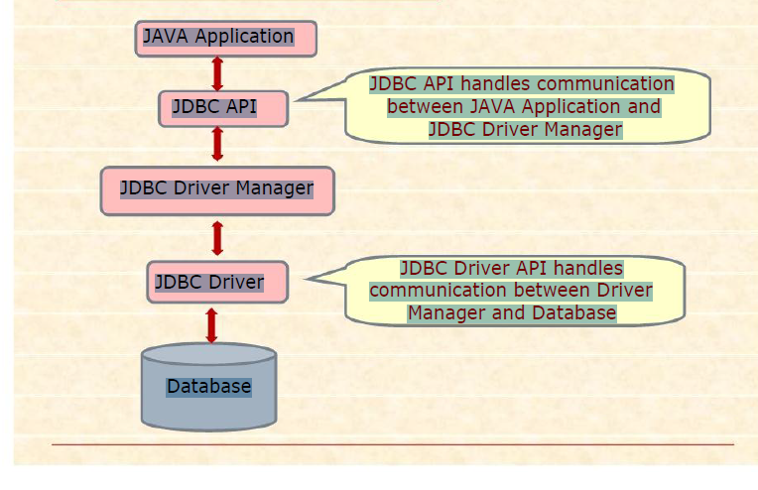

* JDBC API

JDBC is an interface which allows Java code to execute SQL statements inside relational Databases.

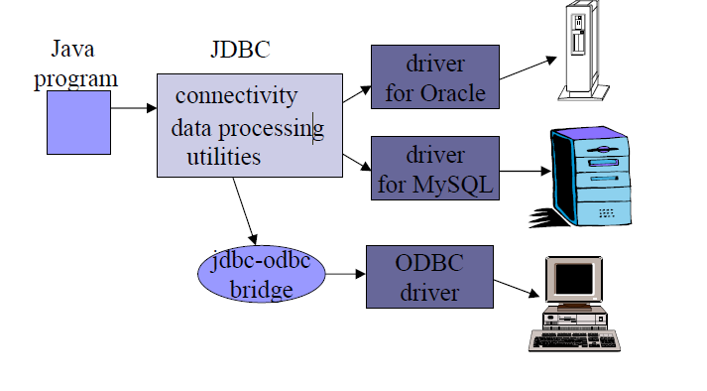

The JDBC-ODBC Bridge

ODBC (Open Database Connectivity) is a Microsoft standard from the mid 1990’s.It is an API that allows C/C++ programs to execute SQL inside databases. ODBC is supported by many products.

JDBC API’s four main classes, which are-

* Driver Manager Class: It loads the JDBC driver to locate logs and access a database.
* Connection Class: It manages communication between Java Client Application and Database, through SQL statements.
* Statement Class: It contains SQL commands which is submitted to the Database Server and returns ResultSet object containing the result of SQL statement.
* Result Set Class: It provides predefined methods to access and convert data values returned by the executed SQL statement.

Steps for JDBC connection

1. Load the JDBC driver

DriverManager is responsible for establishing the connection to the database through the driver.

Class.forName("sun.jdbc.odbc.JdbcOdbcDriver");

1. Specify the name and location of the database being used

The name and location of the database isgiven as a URL

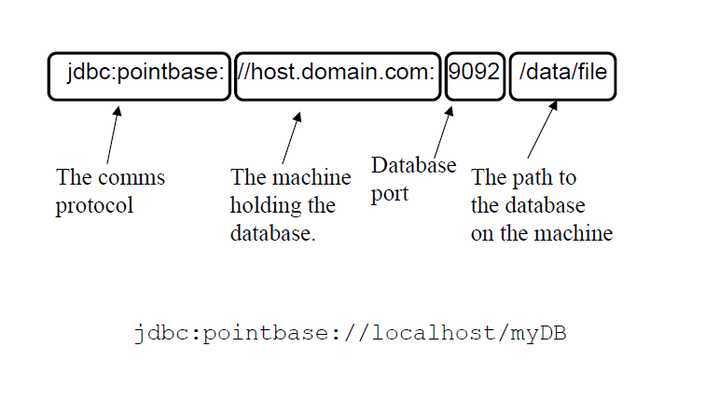

1. Connect to the database with a Connection object

Connection conn =DriverManager.getConnection(url);

1. Execute a SQL query using a Statement object

The Statement object provides a workspace where SQL queries can be created, executed, and results collected.

1. Get the results in a ResultSetobject

rs.getString("lastName")

1. Finish by closing the ResultSet, Statement and Connection objects

rs.close()

st.close()

con.close()

Chapter 2

System Requirements Specification

A computerized way of handling information about videos and users details is efficient, organized and time saving, compared to a manual way of doing. This is done through a database driven web application whose requirements are mentioned in this section.

* OverallDescription

A reliable and scalable database driven web application with security features, that is easy to use and maintain is the requisite.

* SpecificRequirements

The specific requirements of the VMATE are stated as follows:

* SoftwareRequirements

Technology used:

* Front end –JSP
* Controller –JSP/Servlets
* Backend –SQL

Software:

* IDE - Net beans8.2
* Database support - MySQL5.7
* Operating system – Windows 8 andabove
* Server deployment - Glassfishserver

Technology:

* HTML is integrated in JSP. It provides a means to structure text based information in a document. It allows users to produce web pages that include text, graphicsand hyperlinks.
* JavaScript is a scripting language which supports the development of both client and server applications. It is preferred at client side to write programs that can be executed by a web browser within the context of a webpage.
* CSS(Cascading Style Sheets) is a style sheet language used for describing the presentation of a document written in a markup language. Although most often used to set the visual style of web pages and user interfaces written in HTML and XHTML, the language can be applied to any XMLdocument.
* SQL is the language used to manipulate relational databases. It is tied closely with the relational model. It is issued for the purpose of data definition and data manipulation.
* Java Server pages are a simple yet powerful technology for creating and maintaining dynamic-content web pages. It is based on the Java programming language. It can be thought of as an extension to servlet because it provides more functionality than servlet. A JSP page consists of HTML tags and JSP tags. The JSP pages are easier to maintain than servlet because we can separate designing and development.
* jQuery is a concise and fast JavaScript library that can be used to simplify event handling, HTML document traversing, Ajax interactions and animation for speedy website development. jQuery simplifies the HTML's client-side scripting, thus simplifying Web 2.0 applications development.

We require a JDBC connection between the front end and back end components to write to the database and fetch required data.

* HardwareRequirements
* Processor – Intel core I5
* RAM – 2 GB or more
* Hard disk – 3 GB or more
* Chapter 3

Detailed Design

* Systemdesign

The web server needs a JSP engine, i.e., a container to process JSP pages. The JSP container is responsible for intercepting requests for JSP pages. A server (generally referred to as application or web server) supports the Java Server Pages. This server will act as a mediator between the client browser and a database. The following diagram shows the JSP architecture.

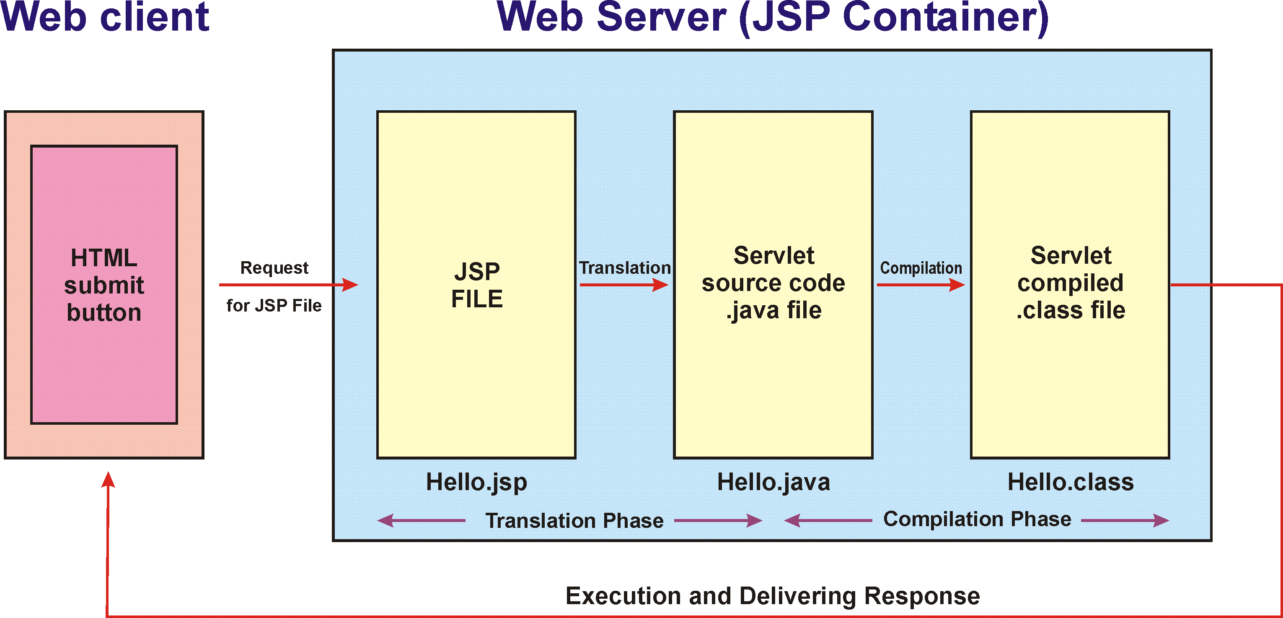

Fig 3.1 JSP architecture

JSP Architecture Flow

* The user goes to a JSP page and makes the request via internet in user’s web browser.
* The JSP request is sent to the Web Server.
* Web server accepts the requested .jsp file and passes the JSP file to the JSP Servlet Engine.This is known as **translation**.
* If the JSP file has been called the first time then the JSP file is parsed otherwise servlet is instantiated. The next step is to generate a servlet from the JSP file. This is known as **compilation**.The generated servlet output is sent via the Internet form web server to users web browser.
* Now in last step, HTML results are displayed on the user’s web browser as **response**.

Three-tier Client / Server database architecture is commonly used architecture for web applications. Intermediate layer called Application server or Web Server stores the web connectivity software and the business logic (constraints) part of application used toaccess the right amount of data from the database server. This layer acts like medium for sending partially processed data between the database server and theclient.

Database architecture focuses on the design, development, implementation and maintenance of computer programs that store and organize information for businesses, agencies and institutions.

A database architect develops and implements software to meet the needs of users. Several types of databases, including relational or multimedia, may be created. Additionally, database architects may use one of several languages to create databases, such as structured query language (SQL). SQL is a database computer language designed for the retrieval and management of data in a relationaldatabase.

* ERDiagram

An entity–relationship model is usually the result of systematic analysis to define and describe what is important to processes in an area of a business.

An E-R model does not define the business processes; it only presents a business data schema in graphical form. It is usually drawn in a graphical form as boxes (entities) that are connected by lines (relationships) which express the associations and dependencies between entities.

An ER model can also be expressed in a verbal form, for example: one building may be divided into zero or more apartments, but one apartment can only be located in one building.

Entities may be characterized not only by relationships, but also by additional properties (attributes),whichincludeidentifierscalled"primarykeys".Diagramscreatedtorepresent attributes as well as entities and relationships may be called entity-attribute-relationship diagrams, rather than entity-relationshipmodels.

An ER model is typically implemented as a database. In a simple relational database implementation, each row of a table represents one instance of an entity type, and each field in a table represents an attribute type. In a relational database a relationship between entities is implemented by storing the primary key of one entity as a pointer or "foreign key" in the table of another entity.

There is a tradition for ER/data models to be built at two or three levels of abstraction.

Note: The conceptual-logical-physical hierarchy below is used in other kinds of specification, and is different from the three schema approach to software engineering.

It is useful for organizing data that can be represented by a relational structure, an entity-relationship diagram can't sufficiently represent semi-structured or unstructured data, and an ER Diagram is unlikely to be helpful on its own in integrating data into apre- existing informationsystem.

Three main components of an ERD are

* the entities ,
* the relationship between those entities, and
* the cardinality,

which defines that relationship in terms of numbers.

Cardinality notations define the attributes of the relationship between the entities. Cardinalities can denote that an entity is optional (for example, a salesman could have no customers or could have many) or mandatory (for example, there must be at least one product listed in an order.)

The three main cardinal relationships are:

* One-to-one (1:1) - For example, if each customer in a database is associated with one mailingaddress.
* One-to-many (1:M) - For example, a single customer might place an order for multiple products. The customer is associated with multiple entities, but all those entities have a single connection back to the same customer.
* Many-to-many (M:N). For example, at a company where all call center agents work with multiple customers, each agent is associated with multiple customers, and multiple customers might also be associated with multipleagents.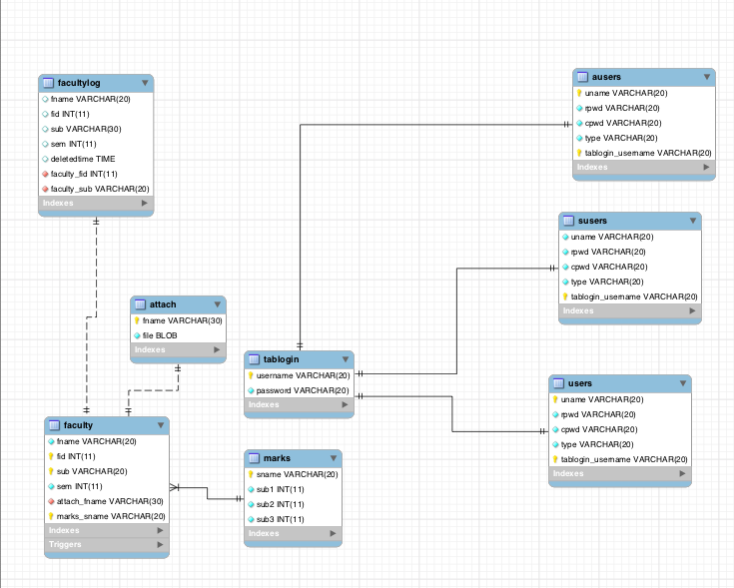

Fig 3.2 EER diagram for SIGHT with Tables

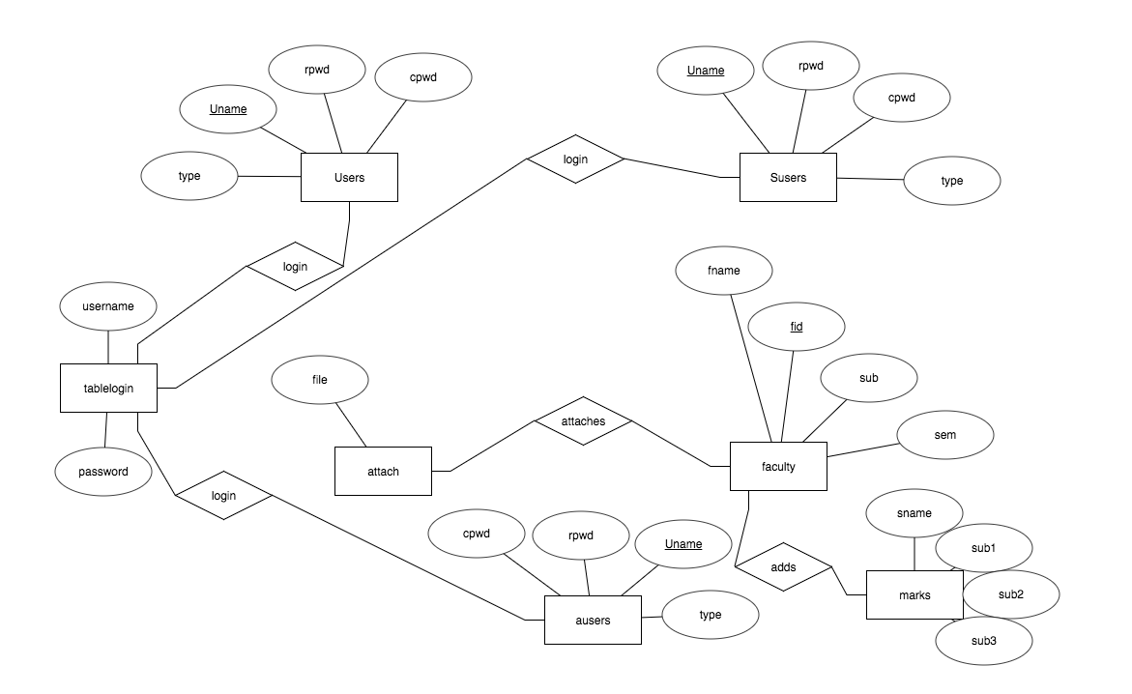

Fig 3.3 E-R diagram

* RelationalSchema

The term "schema" refers to the organization of data as a blueprint of how the database is constructed (divided into database tables in the case of relational databases). The formal definition of a database schema is a set of formulas (sentences) called integrity constraints imposed on a database.

A relational schema shows references among fields in the database. When a primary key is referenced in another table in the database, it is called a foreign key. This is denoted by an arrow with the head pointing at the referenced keyattribute.

A schema diagram helps organize values in the database. It also gives an idea of what order the tables should be created in. The following diagram shows the schema diagram for the database.

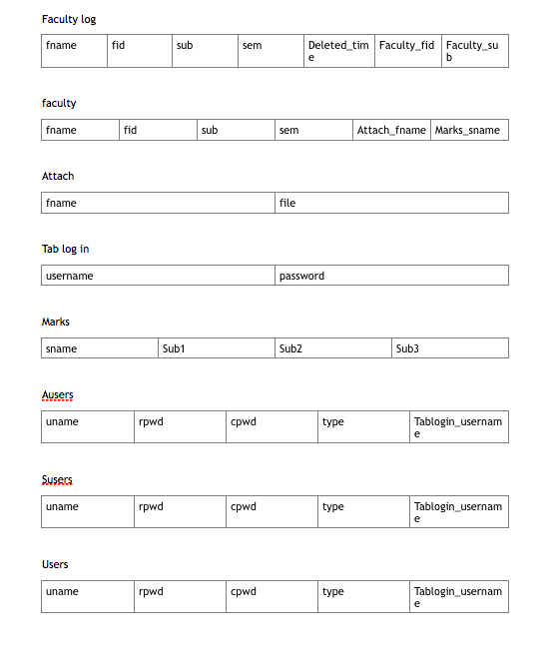

Fig 2.3 Schema diagram

The database SIGHT consists of five tables:

1. Users - storing user details

2. Faculty – storing student details, marks and assignment

3. Admin – has the authority to add faculty

4. Marks- contains student academic details

5. Attach – contains assignment files

USERS

·Userid – Primary key. Generated by auto increment. Identifies user uniquely

·Username – Unique username given by user during registration. This is used during login

· Password – Used during login

· Confirm Password – Confirm password

Chapter 4

Implementation

* Modules and theirrequirements

Administrator module:

A new user can register by providing their name and details with a unique username. The user can login with their Email-ID and password.

Allows administrator to create a channel of public interest where he can add, or delete the videos. He also has the authority to delete the unauthorized videos uploaded by customers. He adds category where users can upload videos on those categories.

User module:

A new user can register by providing their name and contact details with a unique username. The user can login with their Email-ID and password.

Allowsusers to create a channel based on categories of his or her interest. They can upload the videos which can be viewed by other users. The useris given rights toview the videos which he/she had uploaded on his/her channel.

Triggers and stored procedures:

The project makes use of a trigger to compile videos deleted by the admin. A trigger is applied on the sports table. This gets the details of the deleted videos by the admin. .

A stored procedure is used to tostore the details of users and administators who signup.

* Result

The resulting system is able to:

* Authenticate user credentials during login
* Allows user to quickly and easily search the Assignment.
* Allows admin add Faculty.

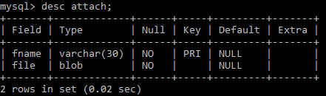

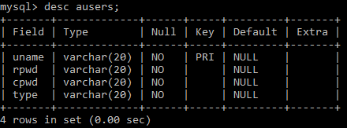

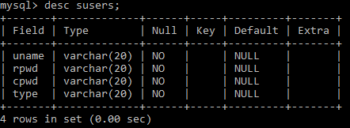

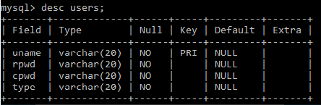

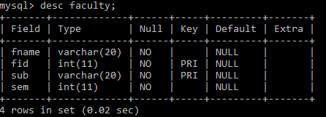

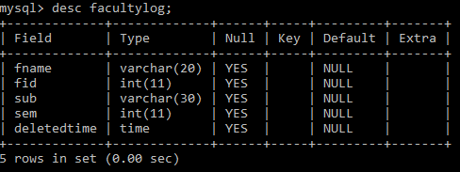

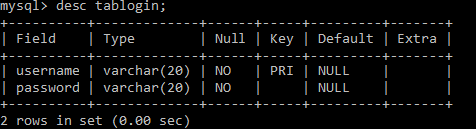

* Stored procedure for signup.







* Triggers for deleted Faculty.



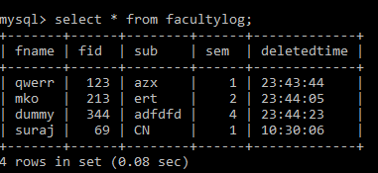

Chapter5

Testing

* [Unit testing:](http://istqbexamcertification.com/what-is-unit-testing/) It is basically done by the developers to make sure that their code is working fine and meet the user specifications. They test their piece of code which they have written like classes, functions, interfaces and procedures.
* [Component:](http://istqbexamcertification.com/what-is-component-testing/) It is also called as module testing. The basic difference between the unit testing and component testing is in unit testing the developers test their piece of code but in component testing the whole component is tested. For example, in a student record application there are two modules one which will save the records of the students and other module is to upload the results of the students. Both the modules are developed separately and when they are tested one by one then we call this as a component or module testing.
* [Integration testing:](http://istqbexamcertification.com/what-is-integration-testing/) Integration testing is done when two modules are integrated, in order to test the behavior and functionality of both the modules after integration.

Chapter 6

Snapshots

This chapter consists of working screenshots of the project with code snippets.

* Registration

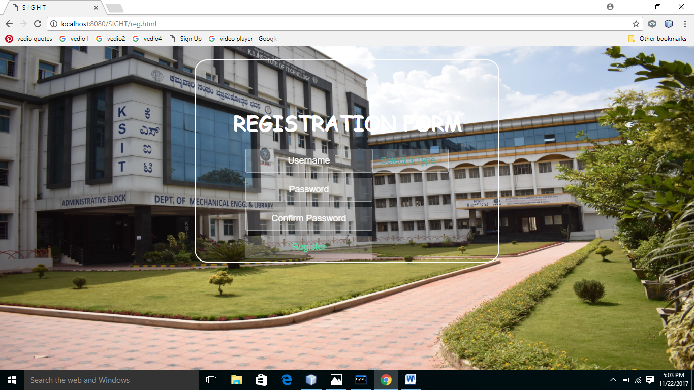

A new user can register with a unique Username, password, and the type of user. The user id is created in the database on successful registration. The user is then redirected to the Login page.

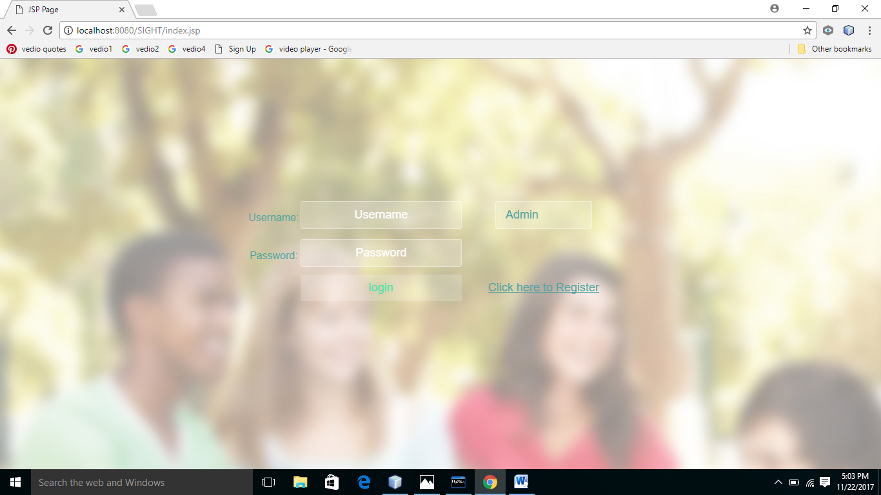

Fig 6.2 The login page

A new user can login with a Email-ID and password. A Email-Id identifies each user in the back end.

A previously registered user can login through this page with valid username and password.

<html>

<head>

<script language="JavaScript">

javascript:window.history.forward(1);

</script>

<meta http-equiv="Content-Type" content="text/html; charset=UTF-8">

<title>SIGHT</title>

<link rel="stylesheet" href="style.css">

</head>

<body background="backround.jpg">

<center>

<div class="wrapper">

<div class="container">

<form align="center" action="Controller" method="POST">

<table align="center">

<tr>

<th>Username:</th>

<td><input type="text" name="uname" placeholder="Username" ></td>

<td>

<select name="items">

<option>

Admin

</option>

<option name="User">

User

</option>

<option name="Staff">

Staff

</option>

</select>

</td>

</tr>

<tr><td></td><tr/>

<tr>

<th>Password:</th>

<td><input type="password" name="pwd" placeholder="Password" ></td>

</tr>

<tr><td></td>

<td>

<input type="submit" value="login" class="btn btn-primary" > </td>

<td><a href="reg.html">Click here to Register</a> </td></tr>

</table>

</form>

</div>

<ul class="bg-bubbles">

<li></li>

<li></li>

</ul>

</div>

</center>

<script src="jquery.min.js"></script>

<script src="index.js"></script>

</body>

</html>

The above snippet makes use of stored procedure reg and vreg to register the details of the user.

THE ADMIN PAGE

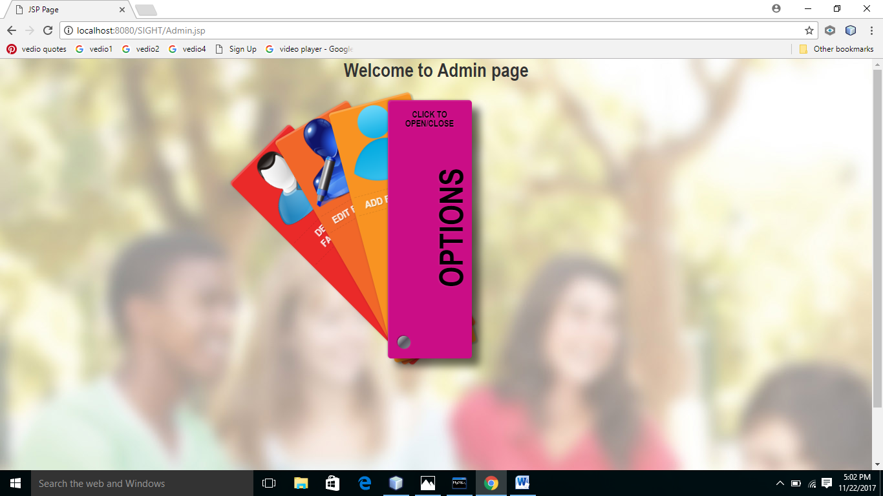

Fig 6.3 The Admin page

The admin is redirected to the admin page on successful registration or login. They will have four options to navigate from here-

* Add Faculty
* Delete Faculty
* Edit Faculty.

.

THE USER PAGE

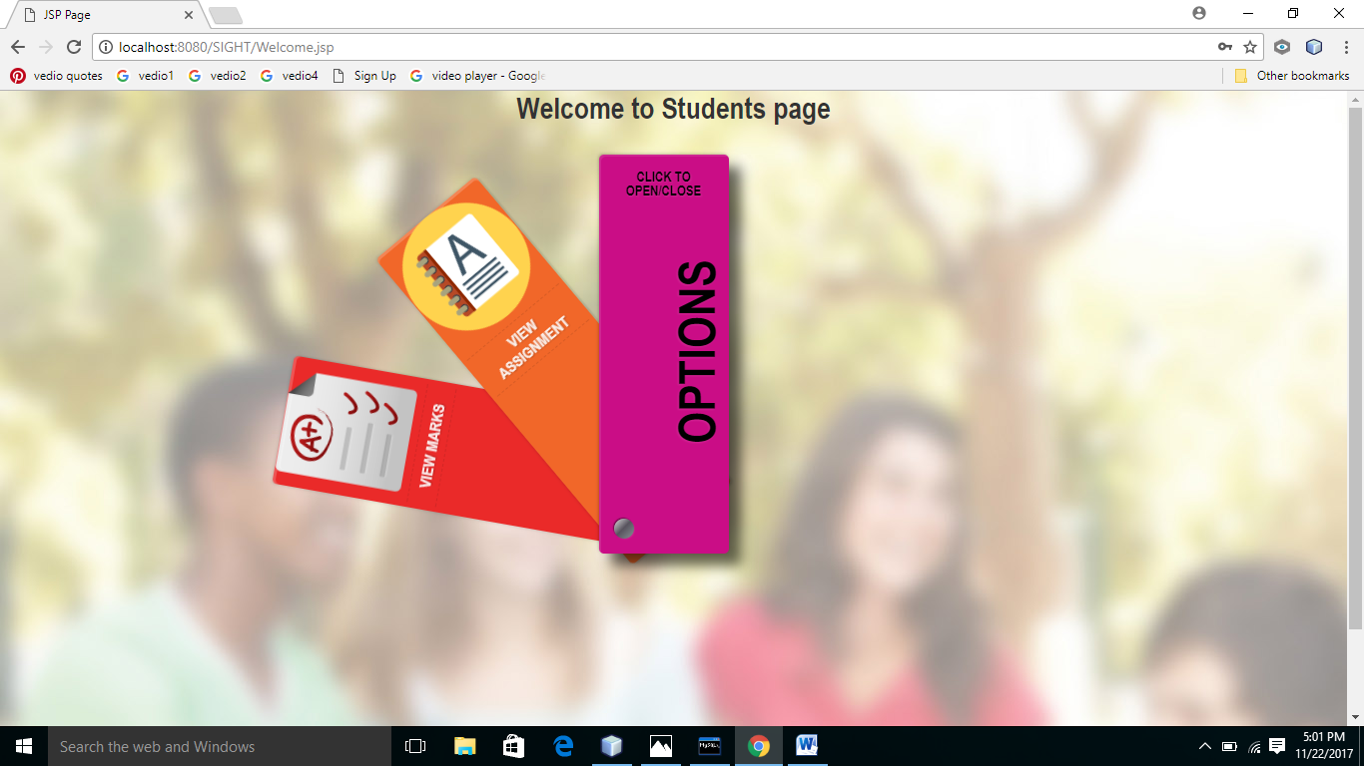

Fig 6.4 User Page

The user is redirected to the homepage on successful registration or login. They will have three options to navigate from here-

* View Assignments
* View Marks.

THE STAFF PAGE

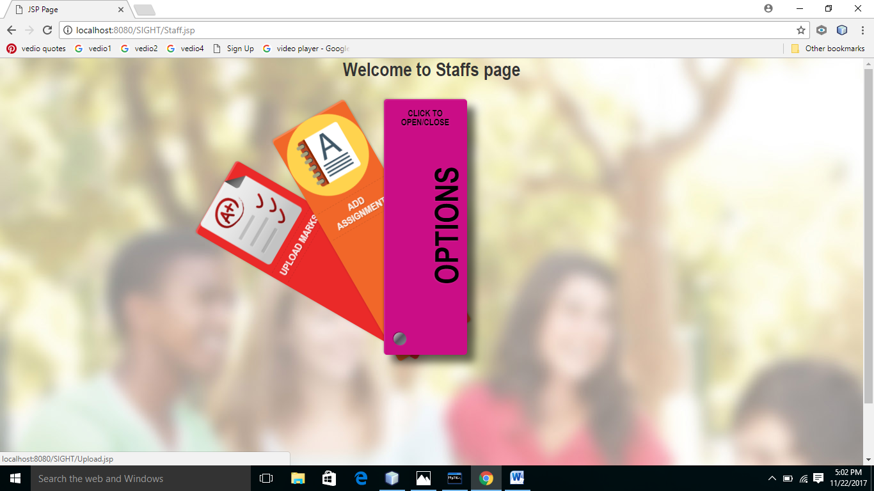

Fig 6.5 Faculty Page

The Faculty has the authority

* Add Assingnment
* Add Marks

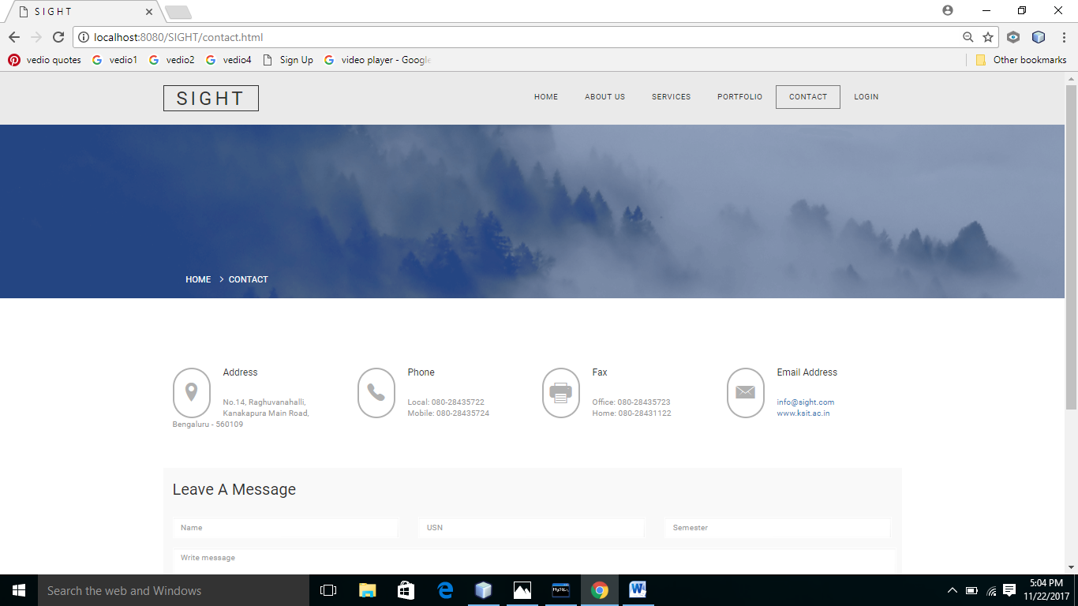

Fig 6.6 Contact page



Fig 6.7 Portfolio

Suppose a user wants to view the assignment , all the assignment uploaded by different faculty with their details are available. They can view more details about a assignment they are interested in.

<html>

<head>

<meta http-equiv="Content-Type" content="text/html; charset=UTF-8">

<title>SIGHT</title>

</head>

<body>

<%@ page import ="java.sql.*" %>

<%@ page import ="javax.sql.*" %>

<%

Class.forName("com.mysql.jdbc.Driver").newInstance();

java.sql.Connection con = DriverManager.getConnection("jdbc:mysql://localhost:3306/Login",

"root","tiger");

Statement st=con.createStatement();

ResultSet rs = st.executeQuery("select * from faculty");

%>

<form action="download1.jsp" method="post" >

<table border="1">

<tr>

<th>Faculty Name</th>

<th>Assignment</th>

</tr>

<tr>

<td>

<select name="fname">

<%

Statement st1=con.createStatement();

ResultSet rs1 = st1.executeQuery("select fname from faculty");

while(rs1.next())

{

out.println(rs1.getString(1));

%>

<option value="<%=rs1.getString(1) %>"><%= rs1.getString(1) %></option>

<%

}

String _fname=request.getParameter("fname");

%>

</select>

</td>

<td><input type="Submit" name="download" value="download"/></td>

</tr>

</table>

</form>

</body>

</html>

Chapter 8

Future enhancements

The currently developed project can improve in many areas. Time constraint and deficient knowledge has been a major factor in limiting the features offered by this mini-project.

Future upgrades to this project will implement:

* Face detection – If a person moves from the screen the video will be paused automatically .
* Reference video – Reference video in Student Page where a student can refer video’s in order to complete the assignment
* Connect –Will bring it to real time webpage which is connected to a host and a domain

Chapter 9

References

* Ramakrishnan, R., &amp; Gehrke, J. (2011). Database management systems. Boston: McGraw-Hill.
* Monson-Haefel, R. (2007). J2EE Web services. Boston, Mass.:Addison-Wesley. Silberschatz, A., Korth, H. F., &amp; Sudarshan, S.(2011).
* Database systems concepts. EstadosUnidos: McGraw-Hill Companies,Inc.
* Hanna P. (2002): JSP 2.0 The Complete Reference, Second Edition McGraw Hill Education;
* David F. (2011). JavaScript: The Definitive Guide Sixth edition.Shroff
* StackOver Flow
* W3-Schools